Grayson Aftermarket Research Questionnaire

As a Business, Grayson Thermal Systems are always looking at ways in which we can continue to satisfy our customers and improve our services. The below questionnaire covers a few topics that we would greatly appreciate your feedback on and it will help us to ensure that we are providing the right products and services to meet your needs.

Our vision is to provide the industry with superb quality tested and verified long-life products along with maintenance and servicing that is second to none. Longevity and reliability of the products and service we supply are paramount as Grayson want to be known industry-wide as THE GO TO company for reliability and excellence in product quality and service to save you time and money over and over again.

GTS recognise that they need to bring real value to their client base, and the real cost of failing components comes from vehicle down time and off the road cost, labour / resource costs. We hope to bring value by delivering long life products to the market.

HEATING.

GTS proposes to develop complete Heater Kits consisting of Long Life components that will warm vehicles consistently, ensure happy drivers and passengers, increase uptime and reduce overall costs.

The Kit includes:
- Heater Coil (High Pressure)
- Magnetic Drive (seal less) Pump
- Long Life Brushless Blowers - Screen Blower, Demister Blower
- Demister Motor Water Valve
- Saloon Cool Lower/Upper
- Saloon Blower with Harness
- Solenoid Diaphragm kit

The hardware is warranted for 5 years including filters subject to meeting specified maintenance conditions.

Would this be of interest to you?

Yes, Definitely
Maybe
No, Not Interested
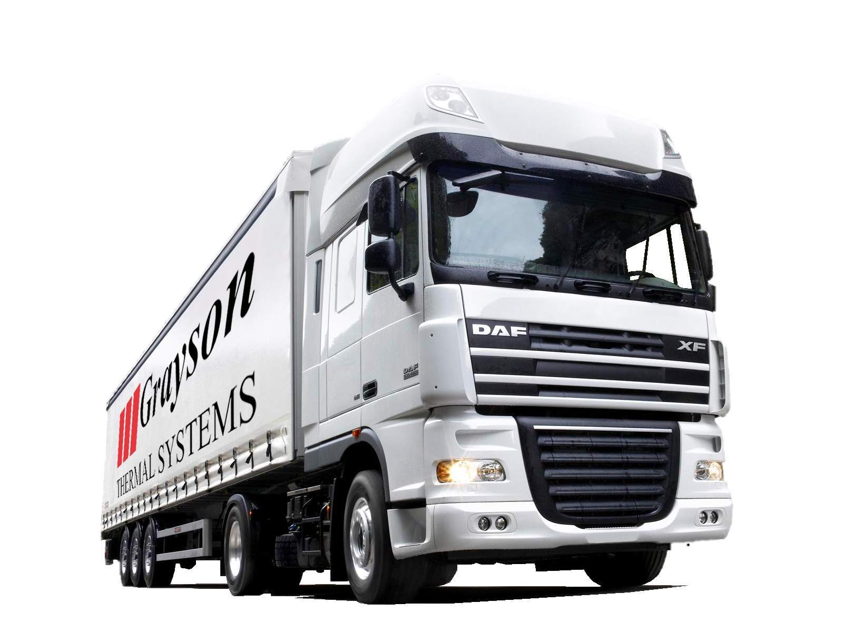
Further Comments:

STANDARD HOSE RANGE

GTS has researched and recognised that Coolant Leakage is a major contributor to vehicle unreliability and are still common-place. We are committed to supplying only High Quality Assured Hoses that deliver exceptional reliability and mean that you see a longer life and fewer problems that cause VOR situations. Our hoses have been validated beyond OEM standards with 1000 000 pressure cyle test and come with a 5 Year Parts Warranty.

We want to know if you are prepared to slight price premium to purchase UK manufactured, high quality product, rather than hoses manufactured off-shore?

Yes, I am prepared to pay a premium for better quality products
Maybe, Need more information
No, Cost is the predominant factor when choosing hose products
Further Comments:

HOSE KITS WITH HOSES AND CLIPS

GTS has identified that in many applications there are 5 or 6 hoses that have a higher failure record those on the remainder of the vehicle. For your convenience we would like to supply your operation with a Hose Kit, consisting of the 5 or 6 high offending hoses that result in consistent vehicle down-time plus the Clips required for fitting. A 5 Year parts warranty is included as standard.

Would you consider purchasing a complete Hose Kit with clips so that all included hoses can be changed at the same time? This will mean the vehicle down time is reduced and furthermore it is protected from the date of this change?

Yes, I would be interested
Maybe, Need more information
No, This is not of interest
Further Comments:

HEAT EXCHANGERS SUPPLIED WITH NEW HOSES AND CLIPS

GTS has seen on many occasions that when a new radiator is installed, old, worn hoses and clips are fitted back on, resulting in second or third time vehicle failures / breakdowns after the heat exchanger has been replaced.
We propose to supply radiators with new hose and clips fitted, so that your technician automatically changes these upon installation. By doing this, you ensure that the vehicle is more reliable for an extended period, increasing uptime and ultimately saving unnecessary downtime and lost revenue.

Is this something that would be of interest to you?

Yes, I would be interested
Maybe, Need more information
No, This is not of interest
Further Comments:

HOSES AND CLIPS RANGE

GTS plan to launch a new range of hoses and clips that have been verified to a 1 million pressure cycle and thermally tested to 10,000 cycles. By creating a quality assured selection of hoses and clips that use a proven combination of high quality silicone hose and proven hose clips, we believe this will reduce coolant leakages and secondary failures where old, worn or incorrectly sized hoses and clips have been reused.

Would it benefit you to purchase Hose and Clips combined in a Kit?

Yes, Definitely
Maybe, Need more information
No, would not be of interest
Further Comments:

5 YEAR WARRANTY AND SERVICE PACKAGES

To take away the hassle and cost of vehicle down-time due to avoidable problems and remove risk of fire from hydraulic leaks and other operating issues, GTS propose to offer 5 Year Warranty and Service Packages including inspections in years 2 and 4 and part replacement kits.

Would you be interested in this for:

Please give each option a rating: 1. Very Interested 2. Would Consider 3. Not Interested

Engine Cooling
E-Drive Kit
Long Life Heater Kits
Silicone Hose and Clips Kits
Further Comments / Other Products or services you would like to see in this option:

Thank you again for giving your time to complete this questionnaire.
Further Comments:
If there is anything else you would like to comment on about our products, services, wish list or general remarks, please leave your feedback below.

ONCE COMPLETED PLEASE SAVE AND EMAIL THIS DOCUMENT TO: INFO@GRAYSONTS.COM

